Year 10 Digital Technology

# Setting up your laptop with Python, GIT and VS Code

To set up your laptop for all our exciting adventures in Digital Technology this year (and next year if you are in Applied Computing), please follow these instructions **in order** and **precisely.**

## Step 1 – Installing Python

Note: these instructions are for Windows, but following as closely as you can on Mac should work fine. Mr Matheson has a Mac, so can help once he returns if you get stuck

1. A screenshot of a computer

   Description automatically generatedIn your web browser, go to <https://www.python.org/downloads/> and Click "Download Python 3.12.4" *(if the version has updated since I wrote these instructions, that will work fine)*. Save this file to your Downloads folder.
2. 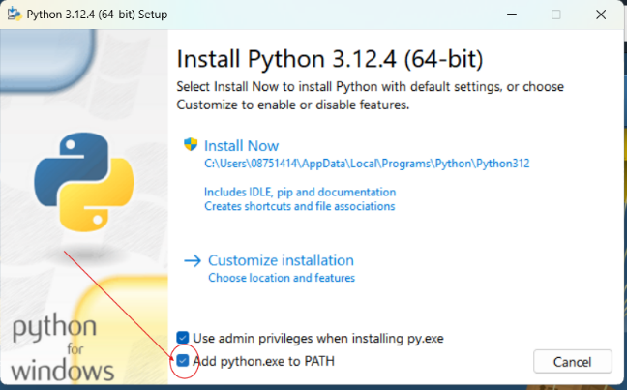 Save and Open the downloaded file (python-3.12.4-amd64.exe or similar)
3. On the installation window, make sure to tick the "Add python.exe to PATH", (see image above) then click "Install Now".
4. 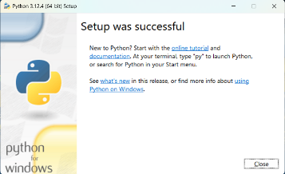 You should now see a success window, which you can close. You should now have Python installed!

## Step 2 – Install Virtual Studio Code

Virtual Studio Code is a professional programming environment (also called IDE for Integrated Development Environment). It might seem intimidating at first, but in the end it will make things easier for us.

1. Visit <https://code.visualstudio.com/> and click "Download for Windows" (or Mac OS X if on Mac)

1. Save and then open the downloaded file (VSCodeUserSetup-x64-1.91.0.exe or similar)
2. Accept the license agreement, then follow the defaults until the "Select Additional Tasks" screen (optional). I recommend ticking each of the boxes as shown below:

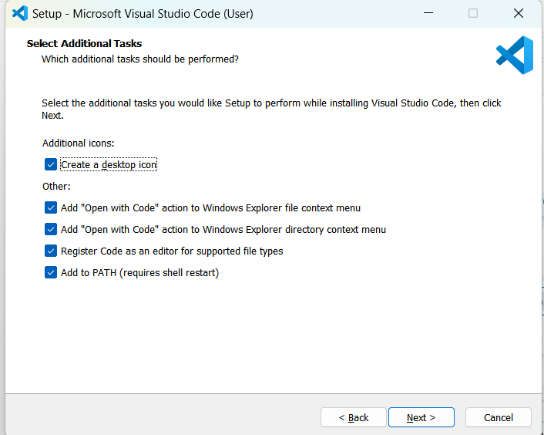

1. Continue with the installation from there and check that Virtual Studio Code opens. Close it for the time being.

## Step 3 – Install Git

Git is a tool for "source control" – it will let us collaborate on code together, make it easy for you to share your code with Mr Matheson and let you get access to programs and resources from Mr Matheson without needing to download files one at a time.

1. Visit <https://git-scm.com/downloads> and click "Download for Windows" A screenshot of a computer

   Description automatically generated
2. Choose "Click here to download" on the screen and save the file (Git-2.45.2-64bit.exe or similar).
3. Open the downloaded file and follow the installation process until the "Choosing the default editor used by Git". Select "Use Virtual Studio Code as Git's default editor". (this isn't the most important, but it might be helpful)

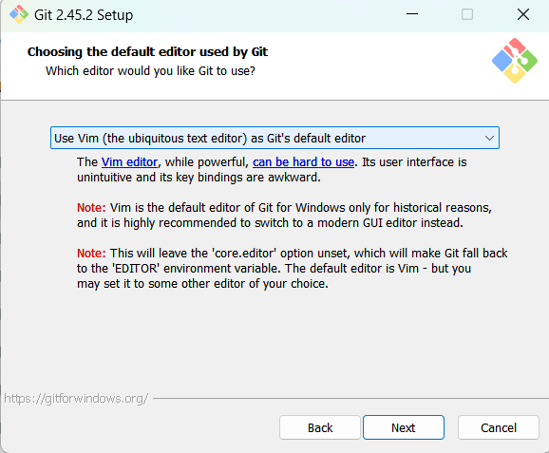

1. Continue with the installation using the default options until Git is installed.

## Step 4 – Visual Studio Code Extensions

1. Re-open Visual Studio Code and choose the "Extensions" menu (see image or the shortcut: Ctrl – Shift – X)
2. You need to install a series of Extensions. To install, type the name of the extension into the search field, then click "Install".   
   **Extensions:**
   * Python Extension Pack
   * GitLens
   * indent-rainbow
   * Jupyter